**Designing The SetQuestionsFrame**

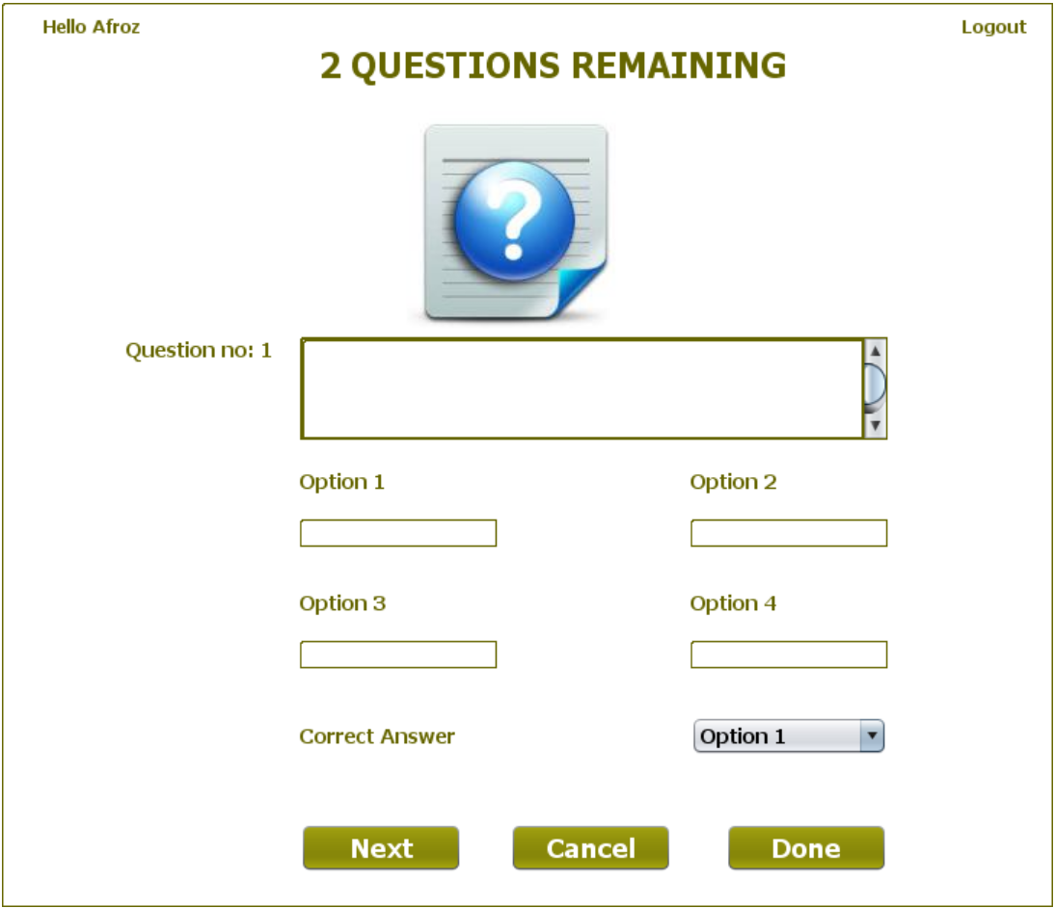

**STEPS TO BE DONE IN** **SetQuestionsFrame**

In the **SetQuestionsFrame** we need to do following steps:

1. Handle the constructor for proper initialization of class members

2. Allow the user to **logout**

3. Write code for the "**Next**" Button . When this button is clicked it should:

**a. Validate the inputs. If validation fails it should print the Error Message and return**

**b. It should fill all the details about the question in Question POJO and add the Question POJO object in the qstore.**

**c. Update the remaining questions label**

**d. Stop the user from adding more questions**

4. Write code for the "**Done**" Button. When this button is clicked it should:

**a. Verify if all the questions have been set .If not, then it should ask the user to set all the questions and return.**

**b. If all questions have been set then it should make an entry in the EXAM table and add all the questions to the QUESTIONS table.**

**c. Dispose the current frame and open the AdminOptionsFrame**

5. Write code for the "**Cancel**" Button. When this button is clicked it should:

a**. Dispose the current frame and open the SetPaperFrame**

**THE TABLES USED IN SetQuestionsFrame**

**1. EXAM**

|  |  |  |
| --- | --- | --- |
| **Column Name** | **Data Type** | **Description** |
| **EXAMID** | **Varchar2(10)** | **Contains id of the paper** |
| **LANGUAGE** | **Varchar2(10)** | **Contains the programming language name** |
| **TOTAL_QUESTION** | **Number(4)** | **Contains total number of question present** |

**2.QUESTIONS**

|  |  |  |
| --- | --- | --- |
| **Column Name** | **Data Type** | **Description** |
| **EXAMID** | **Varchar2(10)** | **Contains id of the paper** |
| **QNO** | **Number(5)** | **Represents the Question No.** |
| **QUESTION** | **Varchar2(100)** | **Represents Question Description** |
| **ANSWER1** | **Varchar2(30)** | **Option 1** |
| **ANSWER2** | **Varchar2(30)** | **Option 2** |
| **ANSWER3** | **Varchar2(30)** | **Option 3** |
| **ANSWER4** | **Varchar2(30)** | **Option 4** |
| **CORRECT_ANSWER** | **Varchar2(10)** | **The actual correct answer** |
| **LANGUAGE** | **Varchar2(10)** | **Programming language name** |

**THE POJO CLASSES USED IN SetQuestionsFrame**

1. The **Exam** POJO

2. The **QuestionPojo** POJO

3. The **QuestionStore** POJO

**THE DAO CLASSES USED IN SetQuestionsFrame**

1. The **ExamDAO**

2. The **QuestionDAO**

We will call the method **addExam( )** of **ExamDAO** to add the **Exam** object in the **EXAM** table.

**Handling the constructor:**

The constructor should do the following:

a. Display the username

b. Create a **QuestionStore** object

c. Create a **HashMap** object

d. Set the number of questions in a label

e. Save the **Exam** object passed by **SetPaperFrame** for further use

**Allowing The User To Logout**

Same as AdminOptionsFrame